

|  |
| --- |
| FINAL PROJET  2024 |
|  |
| October 22  PROJECT GROUP  1-eng/ mohammed mofreh  2-eng/ mohammed Gadalla  3-eng/ amera yasser  4-eng/ mahmuod taha |



# Project title // Design and Implement a Small Office Network

1. Objective

The goal of the project is to connect a group of departments with each other through the use of three access switch and One mulity layer switch, designing the basic shape of the project. Number two, connecting the devices to each other. Number three, making the configuration for each switch. and using some of technologies such as VLAN PPP and NAT

2-Background

This design helps the network engineer to build his network at a lower cost due to the use of the vlan technology, which reduces our use of more switches and routers within the network now, and this reduces the cost of building the network

3-Instructions

Configure the network to meet the requirements

4-Requirment

1- designing the basic shape of the project.

2- connecting the devices to each other.

3- making the basic configuration for each switch.

4- Create one, two and three vlan on multilayer switch by using vtp protocol and each switch give them specific names.

5-Add a number of interfaces to each plan according to the design used

6- Link all switches to the multilayer switch by giving it a default  getway.

7- Log in to the multilayer switch and use the DHCP protocol to dynamically distribute IP to the devices used.

8- Connect the multilayer switch router and from it to the service provid

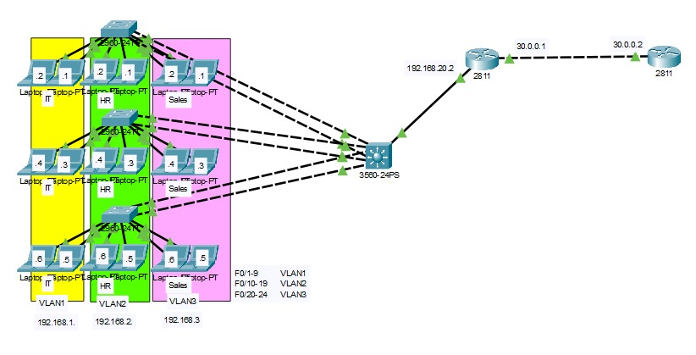

|  |  |  |
| --- | --- | --- |
| Device | Interfac | IP Address |
| Laptop 1 | NIC | 192.168.1.1 |
| Laptop 2 | NIC | 192.168.1.2 |
| Laptop 3 | NIC | 192.168.1.3 |
| Laptop 4 | NIC | 192.168.1.4 |
| Laptop 5 | NIC | 192.168.1.5 |
| Laptop 6 | NIC | 192.168.1.6 |
| Laptop 7 | NIC | 192.168.2.1 |
| Laptop 8 | NIC | 192.168.2.2 |
| Laptop 9 | NIC | 192.168.2.3 |
| Laptop 10 | NIC | 192.168.2.4 |
| Laptop 11 | NIC | 192.168.2.5 |
| Laptop 12 | NIC | 192.168.2.6 |
| Laptop 13 | NIC | 192.168.3.1 |
| Laptop 14 | NIC | 192.168.3.2 |
| Laptop 15 | NIC | 192.168.3.3 |
| Laptop 16 | NIC | 192.168.3.4 |
| Laptop 17 | NIC | 192.168.3.5 |
| Laptop 18 | NIC | 192.168.3.6 |
| Internet Serve | NIC | 8.1.1.1 |
| Internet Serve | NIC | 8.2.2.2 |
| Internet Serve | NIC | 8.3.3.3 |
| Internet Serve | NIC | 8.8.8.8 |
| Internet Serve | NIC | 8.8.4.4 |
| ALX | F0/1 | 192.168.20.2 |
| S0/1/0 | 30.0.0.1 |
| ISP | F0/0 | 8.10.10.10 |
| ISP | S0/0/0 | 30.0.0.2 |

CONFIGURATION

MLS Config

==========

en

conf t

Hostname MLS

int Range f0/1-24

switchport trunk encap dot1q

switchport mode trunk

!!!! sh int trunk

en

conf t

vtp domain cisco

!!!!! sh vtp status

en

conf t

vlan 2

name HR

vlan 3ho

name Sales

!!!!! sh vlan brief

en

conf t

ip routing

int vlan 1

ip add 192.168.1.200 255.255.255.0

no sh

int vlan 2

ip add 192.168.2.200 255.255.255.0

no sh

int vlan 3

ip add 192.168.3.200 255.255.255.0

no sh

!!!! sh ip int brief

!!!! sh ip route

en

conf t

ip dhcp pool IT

network 192.168.1.0 255.255.255.0

default-router 192.168.1.200

dns 8.8.8.8

en

conf t

ip dhcp pool HR

network 192.168.2.0 255.255.255.0

default-router 192.168.2.200

dns 8.8.8.8

en

conf t

ip dhcp pool Sales

network 192.168.3.0 255.255.255.0

default-router 192.168.3.200

dns 8.8.8.8

!!!! sh ip dhcp binding

en

conf t

spanning-tree vlan 1 priority 8192

spanning-tree vlan 2 priority 8192

spanning-tree vlan 3 priority 8192

!!!! sh spanning-tree

en

conf t

int range f0/1-2

channel-group 1 mode on

int range f0/3-4

channel-group 2 mode on

int range f0/5-6

channel-group 3 mode on

!!!! sh etherchannel summary

!!!! sh etherchannel port-channel

en

conf t

int g0/1

no switchport

ip address 192.168.20.1 255.255.255.0

no sh

-------------------------------------------------------------------------------------------

Access Switches

===============

en

conf t

int range f0/10-19

switchport access vlan 2

int range f0/20-24

switchport access vlan 3

!!!! sh vlan brief

en

conf t

int range f0/1-24

spanning-tree portfast

en

conf t

int range f0/1-24

switchport mode access

switchport port-security

switchport port-security mac sticky

switchport port-security violation protect

!!!! sh port-security

!!!! sh port-security int f0/1

!!!! sh run

!!!!!!!!!!!!!!!!!!!!!!!!!!!!!!!!!!!!!!!!!!!!!!!!!!!!!!!!!!!!!

!!!! en

!!!! conf t

!!!! ip dhcp snooping

!!!! ip dhcp snooping vlan 1

!!!! ip dhcp snooping vlan 2

!!!! ip dhcp snooping vlan 3

!!!!en

!!!! conf t

!!!! int r g0/1-2

!!!! ip dhcp snooping trust

!!!! sh ip dhcp snooping

!!!!!!!!!!!!!!!!!!!!!!!!!!!!!!!!!!!!!!!!!!!!!!!!!!!!!!!!!!!!!

en

conf t

int range G0/1-2

switchport mode trun

channel-group 1 mode on

!!!! sh etherchannel summary

!!!! sh etherchannel port-channel

-------------------------------------------------------------------------

Alex Edge Router

---------------

en

conf t

int f0/0

ip add 192.168.20.2 255.255.255.0

no sh

en

conf t

ip route 192.168.1.0 255.255.255.0 192.168.20.1

ip route 192.168.2.0 255.255.255.0 192.168.20.1

ip route 192.168.3.0 255.255.255.0 192.168.20.1

en

conf t

int f0/1

ip add 80.0.0.6 255.255.255.248

no sh

en

conf t

int s0/1/0

encap ppp

ppp authen chap

exit

hostname Alex

username ISP pass cisco

!!!! sh ip int brief

en

conf t

ip route 0.0.0.0 0.0.0.0 s0/1/0

!!! sh ip route

en

conf t

int f0/0

ip nat inside

int s0/1/0

ip nat outside

exit

ip nat inside source list 5 interface s0/1/0 overload

access-list 5 permit any

!!!! sh ip nat translations

=================